BRAUNTON PARISH COUNCIL

Council Offices
Chaloners Road
Braunton
Devon
EX33 2ES

Telephone: 01271 812131
Email: info@brauntonparishcouncil.gov.uk
Website: www.brauntonparishcouncil.gov.uk

Date of issue: 14 September 2023

Dear Councillors: D Spear, M Shapland, V Cann, M Cann, G Bell, R Shapland and L Childs.

You are hereby summoned to attend a meeting of the Braunton Parish Council Parks and Gardens Committee, which will be held on Wednesday 20 September 2023 at 2pm in the Council Chamber, Chaloners Road, Braunton, for the purpose of transacting the undermentioned business.

In accordance with The Public Bodies (Admissions to Meetings) Act 1960 members of the public and press are welcome to attend.

Yours faithfully,
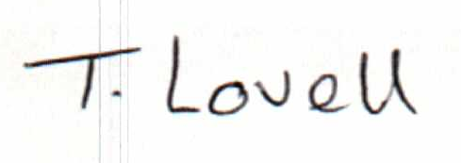

Tracey Lovell BA (Hons)
Clerk to the Council & RFO

- - - - - - - - - - -- - - - - - - - - - - - - - - - - - - - - - - - - - - - - - - - - - - - - - - - - - - - - - - - - - -

AGENDA
Part I – Public

- Apologies – Please make apologies known to the Clerk.
- Declarations of Interest – To receive declarations of personal interests and disclosable pecuniary interests (DPIs) in respect of items on this agenda. Members are reminded that all interests:
- Should be declared at the beginning of the meeting, and
- Declared prior to the item being discussed.

- Minutes Approve and sign the minutes of the Parks and Gardens Committee meeting held on 14 June 2023, attached.

- Section 106 Funding – Consider consultation for new play equipment at the Recreational Ground.

- Poplar trees Caen Overflow Car Park – Agree winter management plan to pollard 21 popular trees.

- Parish Council Tree Management Plan –
- Ash tree Station Close – Consider action to remove diseased Ash tree at Station Close and replace with mature tree resistant to ash die back, information attached.
- Wild Cherry tree nr. Village Green – Consider condition of tree and future management.
- Field Maple tree outside Museum of British Surfing – Consider condition of tree and future management.

- Devon County Council Trees – Consider condition of County trees on the A361.

- Hedgehog Highway Project – Consider taking part in the Hedgehog Highway Project, information attached.

- Invasive Weed Management – consider methods for managing invasive weeds on council land.

- Planter Overflow Car Park under Work Hub window – Approve purchase and installation of a planter.

- Committee Draft Budget 2024/25 – Preliminary discussion.

