BRAUNTON PARISH COUNCIL
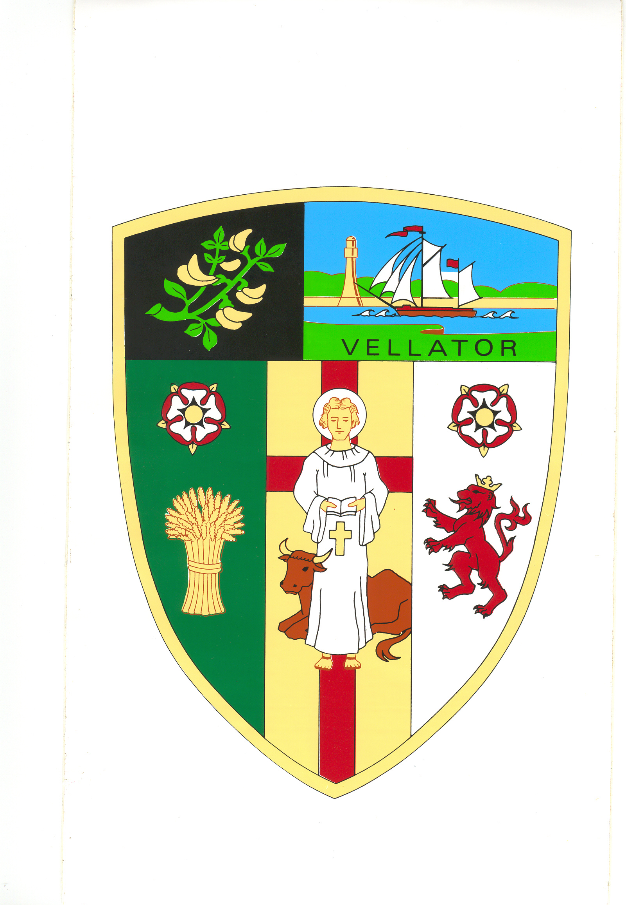
Council Offices
Chaloners Road
Braunton
Devon
EX33 2ES

Telephone: 01271 812131
Email: info@brauntonparishcouncil.gov.uk
Website: www.brauntonparishcouncil.gov.uk

Date of issue: 11 August 2022

Dear Councillors:

You are hereby summoned to attend a meeting of the Braunton Parish Council Parks and Gardens Committee, which will be held on Tuesday 16th August at 2pm in the Council Chamber, Chaloners Road, Braunton, for the purpose of transacting the undermentioned business.

In accordance with The Public Bodies (Admissions to Meetings) Act 1960 members of the public and press are welcome to attend.

Yours faithfully,
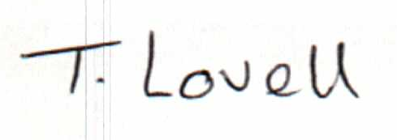

Tracey Lovell BA (Hons)
Clerk to the Council & RFO

- - - - - - - - - - -- - - - - - - - - - - - - - - - - - - - - - - - - - - - - - - - - - - - - - - - - - - - - - - - - - -

AGENDA
Part I – Public

- Elect Chair

- Apologies – Please make apologies known to the Clerk.
- Declarations of Interest – To receive declarations of personal interests and disclosable pecuniary interests (DPIs) in respect of items on this agenda. Members are reminded that all interests:
- Should be declared at the beginning of the meeting, and
- Declared prior to the item being discussed.

- Minutes Approve and sign the minutes of the Parks and Gardens Committee meeting held on 6 December 2021, attached.

- Parish Council Play Parks –
- Consider requests for new equipment.
- Consider updating signage.

- Disused boat planter and machinery planter on grass verges – Consider request to remove and dispose of the boat and machinery planters on roads leading into Braunton.

- Green Waste Removal - Approve cost of skip hire.

