BRAUNTON PARISH COUNCIL
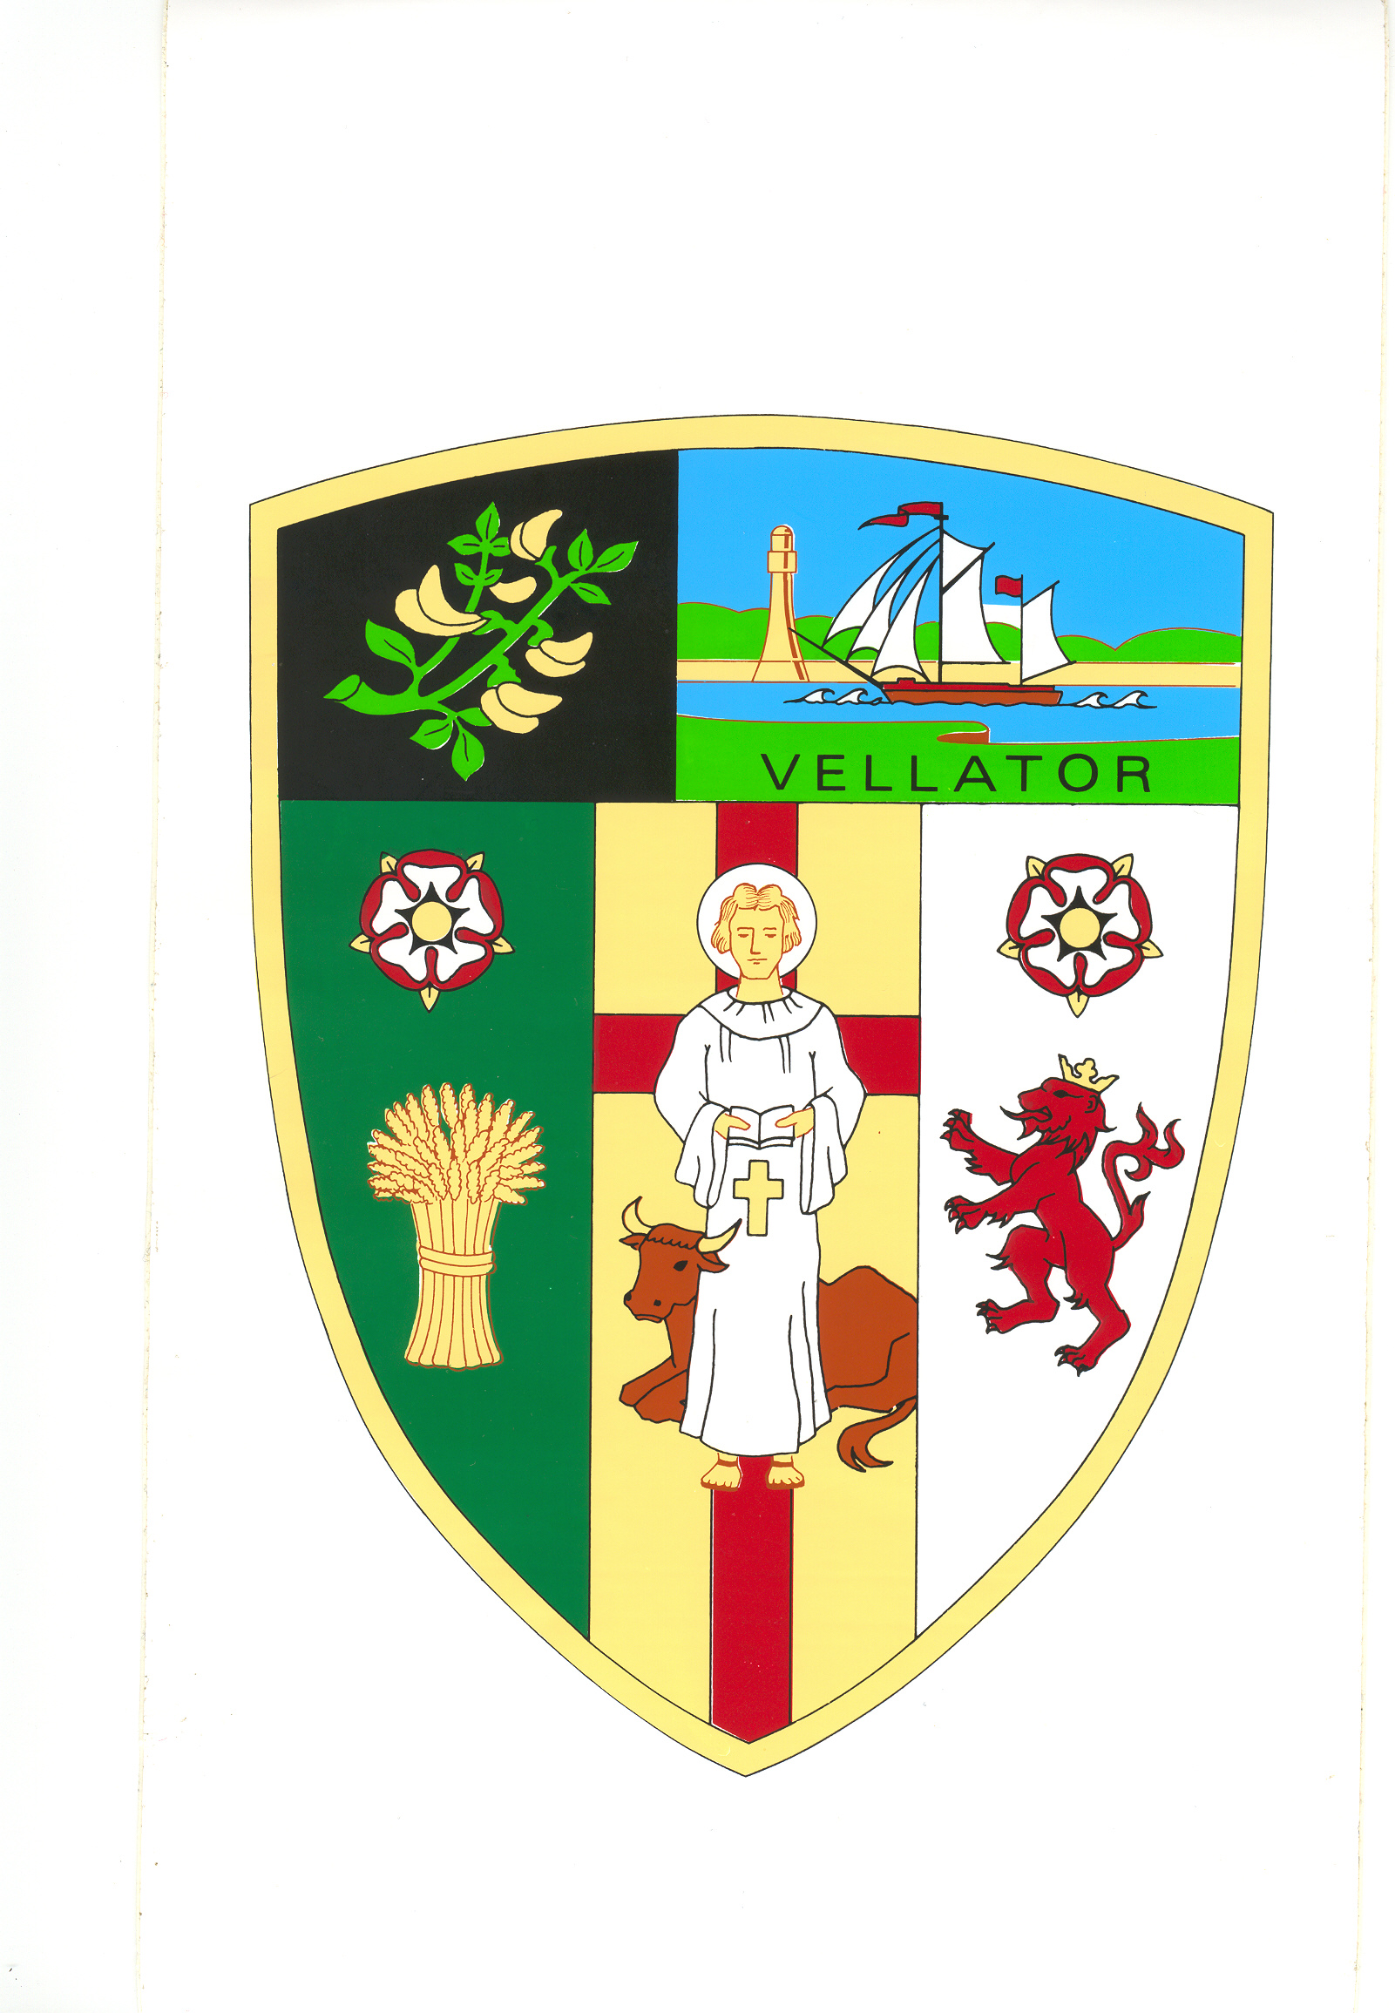
Council Offices
Chaloners Road
Braunton
Devon
EX33 2ES

Telephone: 01271 812131
Email: info@brauntonparishcouncil.gov.uk
Website: www.brauntonparishcouncil.gov.uk

Date of issue: 8 February 2023

Dear Councillors: E Spear, D Spear, D Relph, M Shapland, R Shapland, G Bell and E Wood.

You are hereby summoned to attend a meeting of the Braunton Parish Council Parks and Gardens Committee, which will be held on Monday 13 February 2023 at 2pm in the Council Chamber, Chaloners Road, Braunton, for the purpose of transacting the undermentioned business.

In accordance with The Public Bodies (Admissions to Meetings) Act 1960 members of the public and press are welcome to attend.

Yours faithfully,
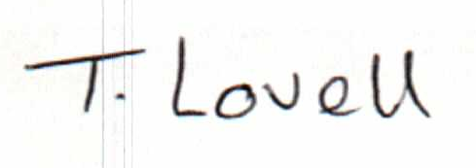

Tracey Lovell BA (Hons)
Clerk to the Council & RFO

- - - - - - - - - - -- - - - - - - - - - - - - - - - - - - - - - - - - - - - - - - - - - - - - - - - - - - - - - - - - - -

AGENDA
Part I – Public

- Apologies – Please make apologies known to the Clerk.
- Declarations of Interest – To receive declarations of personal interests and disclosable pecuniary interests (DPIs) in respect of items on this agenda. Members are reminded that all interests:
- Should be declared at the beginning of the meeting, and
- Declared prior to the item being discussed.

- Minutes Approve and sign the minutes of the Parks and Gardens Committee meeting held on 20 December 2022, attached.

- Section 106 Funding – Consider improvements and enhancements to the Braunton Recreational Ground.

