BRAUNTON PARISH COUNCIL
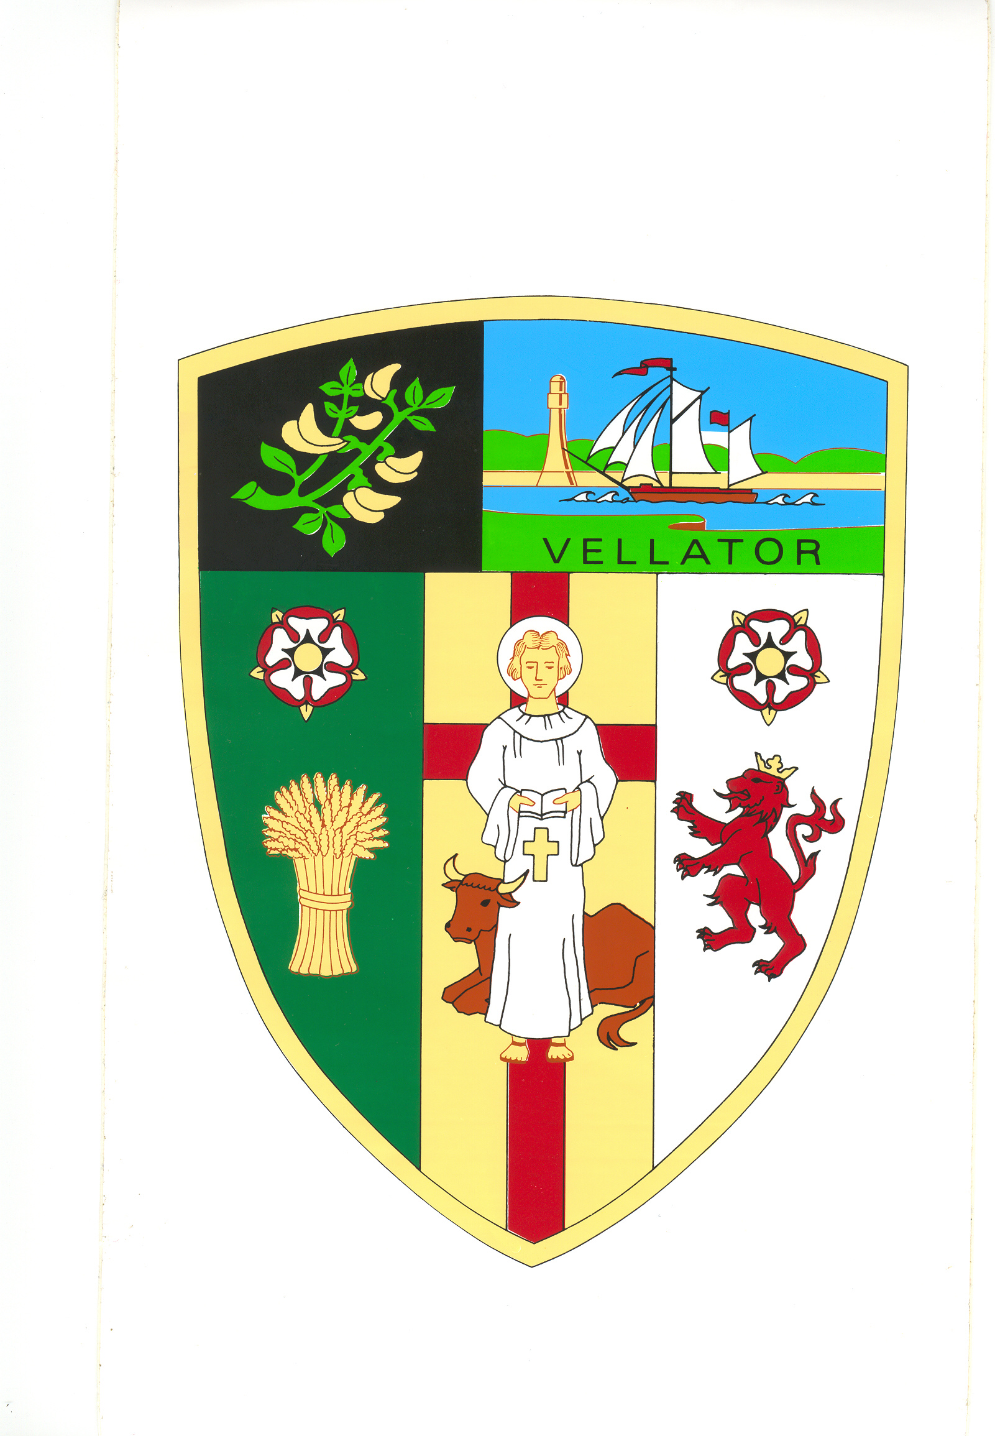
Council Offices
Chaloners Road
Braunton

31 January 2024

Dear Councillors:

You are summoned to attend the Property Committee Meeting of Braunton Parish Council, which will be held on WEDNESDAY 7 FEBRUARY 2024 at 2 pm, in the Council Chamber, Chaloners Road, Braunton, for the purpose of transacting the undermentioned business.

In accordance with The Public Bodies (Admissions to Meetings) Act 1960 members of the public and press are welcome to attend.

Yours faithfully,
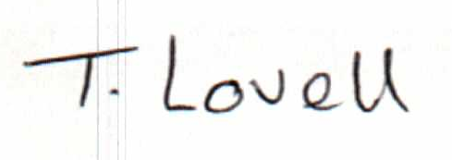

Mrs T Lovell
Clerk to the Council
- - - - - - - - - - - - - - - - - - - - - - - - - - - - - - - - - - - - - - - - - - - - - - - - - - - - - - - - - - - - - -

A G E N D A
Part A - Public

- Receive apologies.

- Declarations of Interest - Councillors are requested to complete the book provided before the meeting.

Interests must be re-declared when the item is called.

- Sign and approve Minutes of the Property Committee meeting held on 9 October 2023, attached.

- Caen Field – Consider request from Caen Primary School to install skate ramp using Active Devon funding.

- Caen Street Boundary Wall – Consider options to prevent future damage to the boundary wall.

- Parish Hall Improvements – Receive Chairman regarding upgrading accessibility to the Parish Hall under the Disability Discrimination Act (DDA).

- To resolve: that under section 1(2) of the Public Bodies (Admission to Meetings) Act 1960 that the public and press be excluded from the meeting for the following item(s) as it involves the likely disclosure of confidential information.

Part B – Exclusion of Press and Public

- Offer of land at Scurfield Close – Consider offer of a strip of land adjacent to the highway in Scurfield Close.

