BRAUNTON PARISH COUNCIL
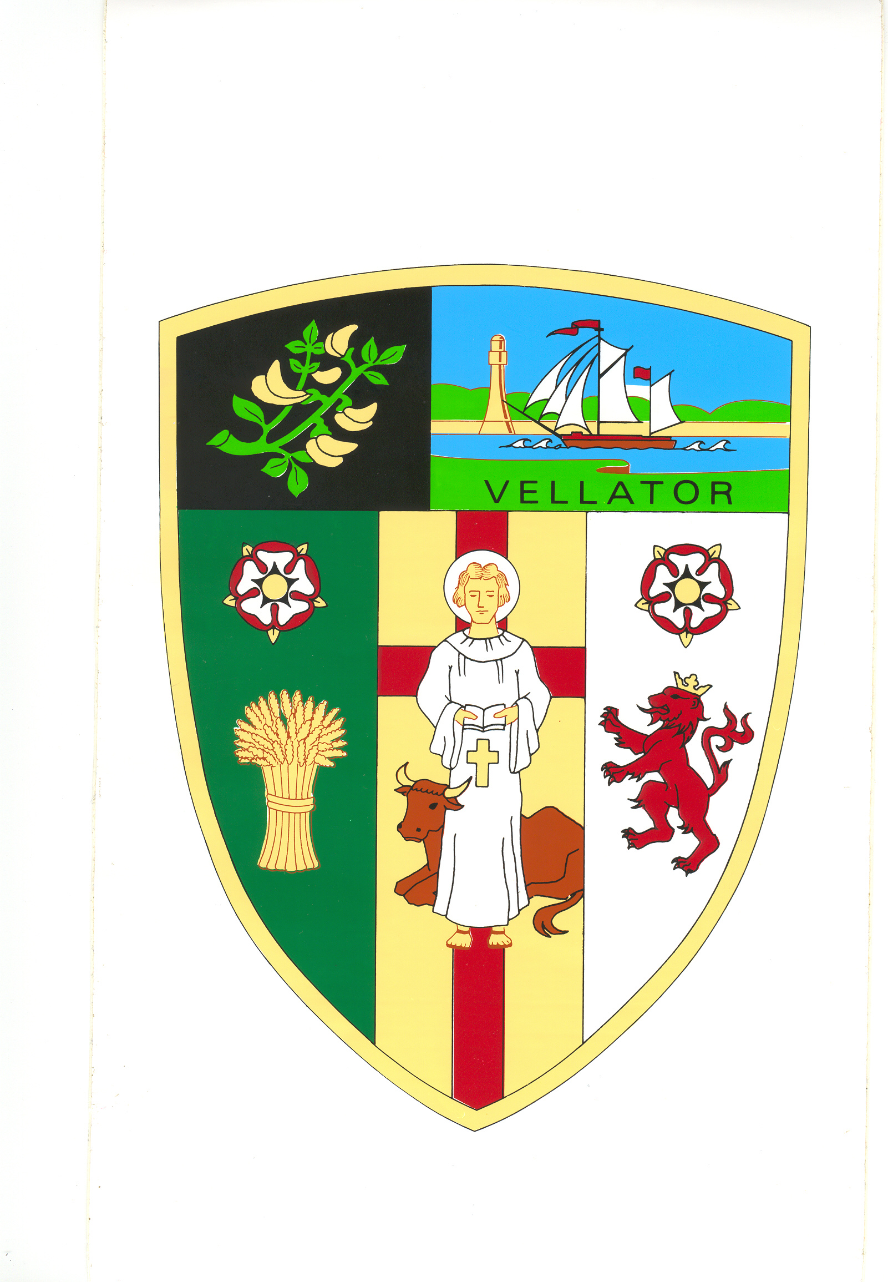
Minutes of the Property Committee meeting held in the Council Chamber at
2:00pm on Tuesday 21 February 2023

Present | Councillors: A Bryant, E Spear, M Shapland, R Shapland, E Wood and V Cann,
In Attendance | Tracey Lovell (Parish Clerk), Angela Corner (Senior Council Officer)
 | Member of Public: Laura Martin (Caen Primary School)
PR/18/2022/23 | Receive Apologies and reasons for absence | None received.
PR/19/2022/23 | Declarations of Interest | There were none.
PR/20/2022/23 | Minutes | The committee noted that the Minutes of the Property Committee meeting held on 20 December 2022 had previously been approved and ratified by Full Council. The Minutes were approved as a correct record and signed by the Chair.  (5.0.1abs)
PR/21/2022/23 | Caen Field | The chair welcomed Laura Martin from Caen Primary School to the meeting.  Caen Community Primary School have been offered unlimited funding from Active Devon to install equipment to encourage children to do 60 minutes active fitness a day. The school would like to install a temporary, movable, wooden skate ramp in the Caen Field for their school children and the community. The funding stipulates that the equipment must be accessible to the wider community. The school are therefore proposing to allow use of the ramp weekdays up until 5.30pm and Saturday mornings. The site would remain locked for the rest of the time.  The Clerk advised that it may require an amendment to the Lease as the Field can only be used by pupils of the school.  RESOLVED:  - That the Clerk to contact Devon County Council to discuss the terms of the Lease.  - Caen Community Primary School to check if the skate ramp would be covered under the school’s insurance. Whether planning consent would be required and to consult with the neighbouring properties regarding noise.  (NC)
PR/22/2022/23 | Vandalism to the Recreational Ground Boundary Wall | Members noted that the boundary wall at the Recreational Ground had been vandalised on two occasions. Several concrete blocks had been removed and left on the ground nearby. The Council staff had managed to collect the removed blocks and store them safely. Both incidents had been reported to the police but unfortunately there were no witnesses, so it is unlikely that the culprits will be found.  RESOLVED: That the Council reinstates the concrete block wall and builds a retaining wall to strengthen the structure from further vandalism. The works to be down in house.  (NC)
PR/23/2022/23 | Free Parking for Disabled Users in the Council Car Parks | Members considered a request from a member of the public for disabled parking in the Council car parks to be free of charge. When visiting the Pharmacy or Medical Centre the disabled bays outside are a long way from the pay and display meters, making it difficult for people with disabilities to obtain a ticket. The Clerk advised that if the disabled bays were free of charge, they would need to be removed from the North Devon Off Street Parking Order. This would result in the bays not being enforced and there possibly being no parking available for disabled users. The Council do operate an App so parking can be paid for without going to the pay and display meters. It was also noted that from the 1 April the 20 minutes short-stay would be extended to 30 minutes giving people more time to visit the Pharmacy or Medical Centre.  RESOLVED: That the disabled bays remain part of the North Devon Off Street Parking Order.  (NC)
PR24/2022/23 | Solar Lighting in Bus Shelter | Members considered a request for solar lighting in the Knowle bus stop outbound to Ilfracombe. It was noted that there are not many Devon County Council street lighting in the area which may make it difficult for bus drivers to see people stood at the bus stop when dark. The Clerk advised that Fernbank had quoted £3,000 to install a solar light and that the panels are prone to theft.  RESOLVED: That the Council  - notifies Stagecoach that it has received complaints that bus drivers are not stopping at this bus stop to pick up passengers when it is dark.  - request if Devon County Council would consider installing additional street lighting in this area.

PR/25/2022/23 | Braunton Community Work Hub | RESOLVED: That the Council  - agrees the new tariff for the Work Hub reducing the Station Office monthly rent to £498.75 inc. VAT. This is to take into account the lobby area which is not part of the office.  - agrees to disconnect the water heating under the kitchen sink to help reduce energy use at the hub.

Meeting Closed at 3pm

……………………………….. The Chair

