BRAUNTON PARISH COUNCIL

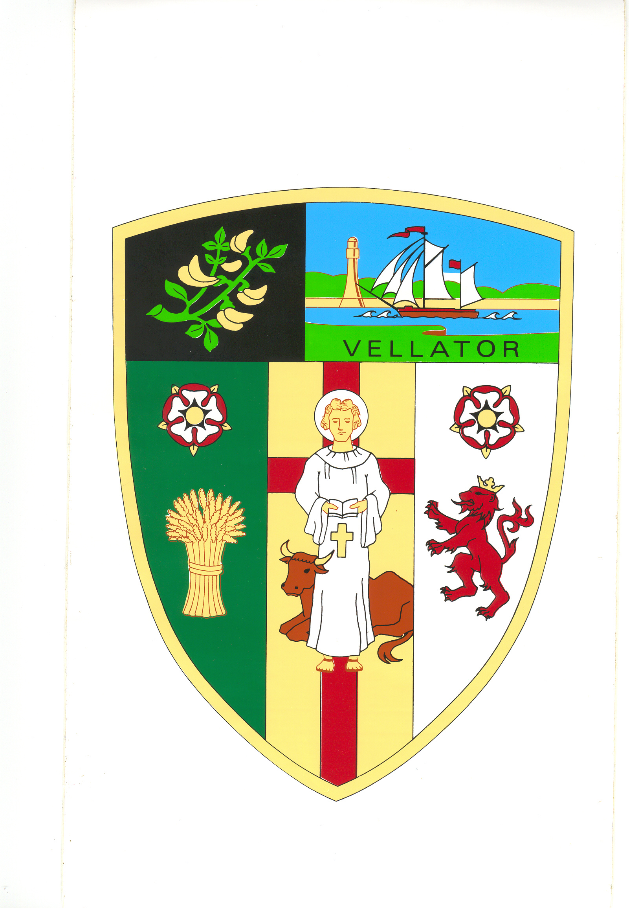
Minutes of the Meeting of the Parks and Gardens Committee held in the Council Chamber at 5.00 pm on Monday 3 June 2019

Present | Cllrs: E Spear, D Spear, M Shapland, R Shapland, Bryant
Also in Attendance |  | Tracey Lovell (Parish Clerk), Angela Corner (Senior Council Officer  1 member of the public
PG/1/2019/20 | Elect Chair |  | Councillor D Spear was nominated and duly elected.  (NC)
PG/2/2019/20 | Apologies |  | Received and accepted from Cllrs Bunyard and Relph.
PG/3/2019/20 | Declarations of  Interest |  | Non-Pecuniary received from Cllr E Spear for agenda item PG/5/2019/20 (ii) as she is a member of Rotary Caen.  Non-Pecuniary received from Cllr D Spear for agenda item PG/5/2019/20 (ii) as he is a member of Rotary Caen.  Non-Pecuniary received from Cllr M Shapland for agenda item PG/5/2019/20 (ii) as she is a trustee of Braunton Countryside Centre.
PG/4/2019/20 | Minutes |  | The committee noted that the Minutes of the Parks and Gardens Committee meeting held on 27 February 2019 had previously been approved and ratified by Full Council. The Minutes were approved as a correct record and signed by the Chair.  (NC)
PG/5/2019/20 | Village Green |  | - Update - The Senior Council Officer advised that phase one was complete and the main funding payments had been received. The interpretation board will be installed prior to the open event.  The footpath closure application now requires 3 months’ notice so phase two will be scheduled in the autumn.  - Open Day – The Clerk advised the Committee of plans to hold an official opening of the village green in conjunction with community groups from 11.30 am - 2.30 pm on Saturday 13 July. She advised that a road closure for the event would not be cost effective.  The sequence of events to be planned as follows:  - Chair to officially open the event  - 12 midday Rev. Anne Thorne to bless the new tree.  - Activities to include local musicians, crafts stalls, Teddy Parachute jump, clown workshop, hotdogs (London Inn), invite local traders/organisations and school children to join in.  Cllrs E Spear, D Spear and M Shapland declared a non-pecuniary interest.  RESOLVED: To recommend to Full Council:  - For Braunton Parish Council to provide:  - crowd control barriers (Braunton Rotary have volunteered some marshals for the event)  - Public Liability insurance of £10m  - Risk Assessment  - PA System  - To allow erection of gazebos on grassed area near the Countryside Centre:- Love Braunton (to display fund-raising material) and Braunton Rotary (for recruitment tent and marshals).  - To invite Mango Beads to put on their craft market possibly outside the Museum of British Surfing and live music to perform on the Community Shared Space.  - To allow Braunton Museum to hold their annual Teddy Parachute event on the village green.  - To promote the event (poster to be approved including all logos) in EX33, local media, social media etc.  - The Clerk to organise a primary school drawing competition with pictures on display in a marquee. Invite local business to provide a prize.  (NC)
PG/6/2019/20 | Summer Planting |  | The Clerk advised that the hanging baskets were already up which had been budgeted for.  The Chaloners Road car park bed has been deferred until after nesting season.  RESOLVED: To recommend to Full Council to:  - To consider planting flower bed at the entrance to Knowle village. Contact Knowle Community Group to find out if they already have any plans.  - To consider more sustainable planting which lasts more than one year and use annuals for spot colour. Refer to Britain in Bloom guidelines.  (NC)
PG/7/2019/20 | Committee Four Year Devlopment Plan |  | The Committee discussed:  - lack of open space available in the village.  - a letter and pictures received from Braunton Rotary Club regarding ideas for open spaces.  - trees and hedges in the village  RESOLVED: To recommend to Full Council to:  - Approve year one of the amended Four Year Development Plan (attached as appendix A)  - To invite Andy Jones and Andrew Moulton from North Devon Council to the next Parks and Gardens Committee meeting.  - To respond to the letter from Braunton Rotary Club to advise ideas would be put into Parish Plan and Parish would refer to the relevant authorities.  (NC)

The meeting closed at 6.21 p.m.

.................................... The Chairman

