BRAUNTON PARISH COUNCIL
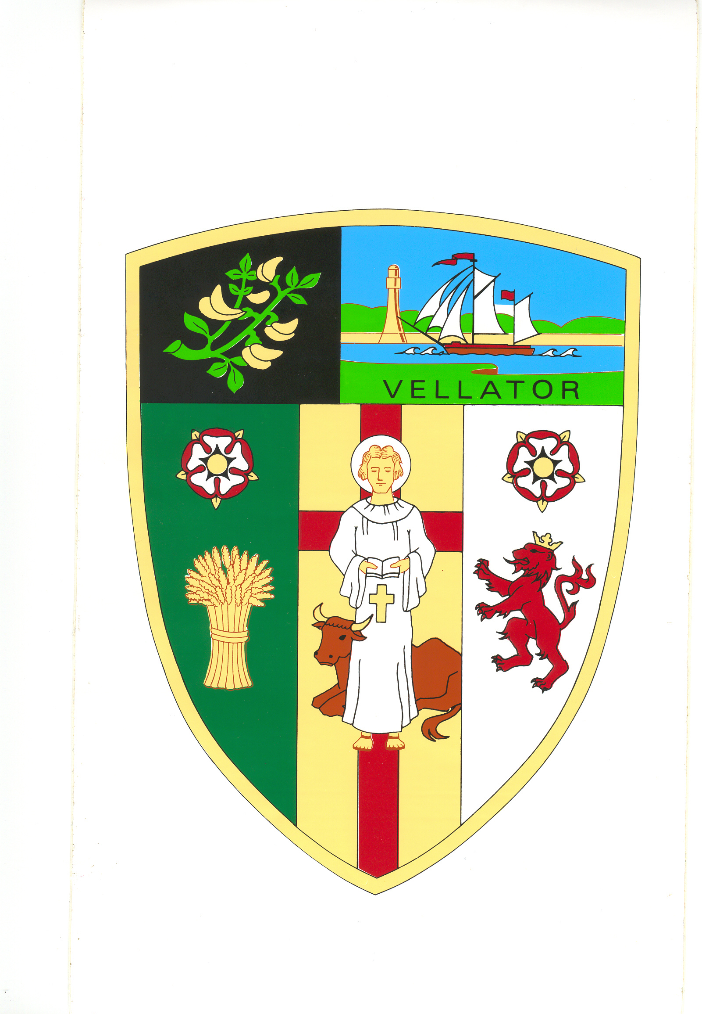
Minutes of the Property Committee meeting held in the Council Chamber at
2:00pm on Tuesday 20 December 2022

Present | Councillors: E Spear, M Shapland, R Shapland, E Wood, V Cann, G Bell
In Attendance | Tracey Lovell (Parish Clerk), Angela Corner (Senior Council Officer)
PR/12/2022/23 | Receive Apologies and reasons for absence | Apologies received and accepted from Cllr A Bryant.
PR/13/2022/23 | Declarations of Interest | There were none.
PR/13/2022/23 | Minutes | The committee noted that the Minutes of the Property Committee meeting held on 12 October 2022 had previously been approved and ratified by Full Council. The Minutes were approved as a correct record and signed by the Chair.  (NC)
PR/14/2022/23 | Velator Quay | - Replacement lifebuoy and cabinet - The committee considered options and quotes.  RESOLVED: To recommend to Full Council to purchase the Housing cabinet designed in consultation with the RNLI on surface mounted post together with a 24” lifebuoy and encapsulated throw line from Lifebuoys Direct at a cost of £437 ex VAT plus £45 shipping.  (NC)  - The committee considered the installation of a container for recycling old fishing lines  RESOLVED: To recommend to Full Council to allow installation of the pipe at the side of the post on the Quay pontoon sign.  (NC)  - Signage to discourage unauthorised parking  RESOLVED: To recommend to Full Council to erect a sign.  (NC)
PR/15/2022/23 | Parish Hall | Replacement of windows in the kitchen and WC -  At the time of the meeting no quotes had been received. The Senior Council Officer will email quotes to members of the committee for consideration.
PR/16/2022/23 | Braunton Community Work Hub | The committee considered the introduction of the new tariff and opportunities to retain occupancy.  RESOLVED: To bring back details to the next meeting.
Part II – In Committee

Matters taken in the absence of Press of Public (Public (Admissions to Meetings) Act 1960) as the item contains exempt information as defined by the Local Government Act 1972 Sch. 12a Pt (1).

PR/17/2022/23 | Braunton Community Work Hub | The Clerk updated the committee on the amounts outstanding and members noted the situation and advised the Clerk to continue to recover arrears.

Meeting Closed at 2.27pm

……………………………….. The Chair

