BRAUNTON PARISH COUNCIL
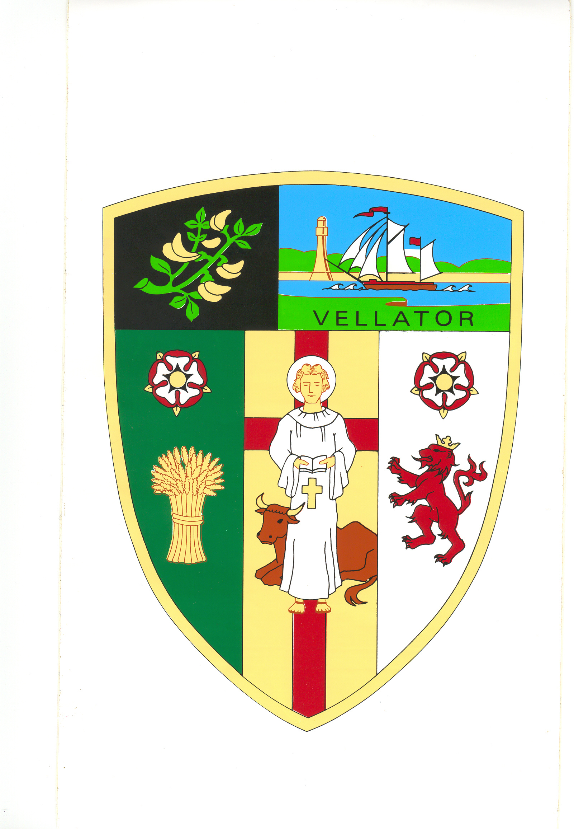
Minutes of the Property Committee meeting held in the Council Chamber at
2:00pm on Tuesday 19 July 2022

Present | Councillors: E Spear, M Shapland, R Shapland, V Cann, A Bryant, E Wood
In Attendance | Tracey Lovell (Parish Clerk), Angela Corner (Senior Council Officer)
PR/1/2022/23 | Elect Chair | There was one nomination, Cllr A Bryant  RESOLVED: That Cllr A Bryant be elected Chair of the Property Committee for the Municipal Year 2022/23.  (NC)
PR/2/2022/23 | Receive Apologies and reasons for absence | None
PR/3/2022/23 | Declarations of Interest | There were none.
PR/4/2022/23 | Minutes | The committee noted that the Minutes of the Property Committee meeting held on 7 December 2021 had previously been approved and ratified by Full Council. The Minutes were approved as a correct record and signed by the Chair.  (4.2abs)
PR/5/2022/23 | Fire Risk Assessment Council Property | The committee considered the quote for the Fire Exit signage required (as identified on the Fire Risk Assessment).  RESOLVED: To recommend to Full Council that West of England Fire Protection install required signage in the Parish Hall, offices and Sports Pavilion at a total cost of £350.00.  (NC)
PR/6/2022/23 | Part II | It was resolved that under Section 1(2) of the Public  Bodies (Admission to Meetings) Act 1960 that the public and press be excluded from the meeting for the following items as they involve the likely disclosure of confidential information  (NC)

PR/7/2022/23 | Pine Tree at Braunton Beacon | The Clerk showed photos of the location and circumstances of the tree to the Committee. The Clerk explained that there had been a boundary dispute regarding ownership of the tree. A tree consultant had been appointed by the Council to look at the tree. The tree consultant advised that the tree should be managed and not felled.  RESOLVED: To recommend to Full Council that the Council  - Write to the property owner stating that the Council are not responsible for the tree, providing evidence including the title deed and a letter from the previous Clerk.  - Request that the owner of the tree remove the limb of the pine tree which overhangs the footpath on parish land.
(NC)
The meeting closed at 2.17 pm.

……………………………………..…Chair

