BRAUNTON PARISH COUNCIL


Council Offices
Chaloners Road
Braunton

Date agenda issued: 31 May 2023

Dear Councillors: M Shapland, V Cann, M Cann, E Spear, G Bell, D Spear and T Kirby

You are summoned to attend the Finance and Administration Committee Meeting, which will be held on the 6 JUNE 2023 at 2pm, in the Council Chamber, Chaloners Road, Braunton, for the purpose of transacting the undermentioned business.

In accordance with the Public Bodies (Admissions to Meetings) Act 1960 members of the public and press are welcome to attend.

Yours faithfully,
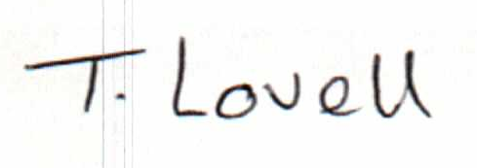

Mrs T Lovell BA (Hons)
Clerk to the Council & RFO
- - - - - - - - - - - - - - - - - - - - - - - - - - - - - - - - - - - - - - - - - - - - - - - - - - - - - - - - - - - - - -
A G E N D A
Part A

- Receive apologies and reasons for absence.

- Declarations of Interest

Interests must be re-declared when the item is called.

- Sign minutes of the Finance and Administration Committee meeting held on the 27 April 2023, attached.

- Receive Financial Reports, as follows: -
a) Actual Income and expenditure against budget
b) Bank transactions
c) Bank Reconciliation to 31 May 2023
d) Trial Balance Report
e) Approve staff timesheets

- Review Council Direct Debits, Standing Orders as per para. 6.7 of the Financial Regulations.

- Recruitment of Administration Assistant – Parish Clerk to update on the recruitment process.

- To resolve: that under section 1(2) of the Public Bodies (Admission to Meetings) Act 1960 that the public and press be excluded from the meeting for the following item(s) as it involves the likely disclosure of confidential information:

Part B

- Staff Matters – to receive update from the Parish Clerk on staffing issues following the job evaluation exercise and amended contracts to reflect the Green Book.

- Tenancies at Braunton Work Hub – Receive update report from the Parish Clerk.

