BRAUNTON PARISH COUNCIL
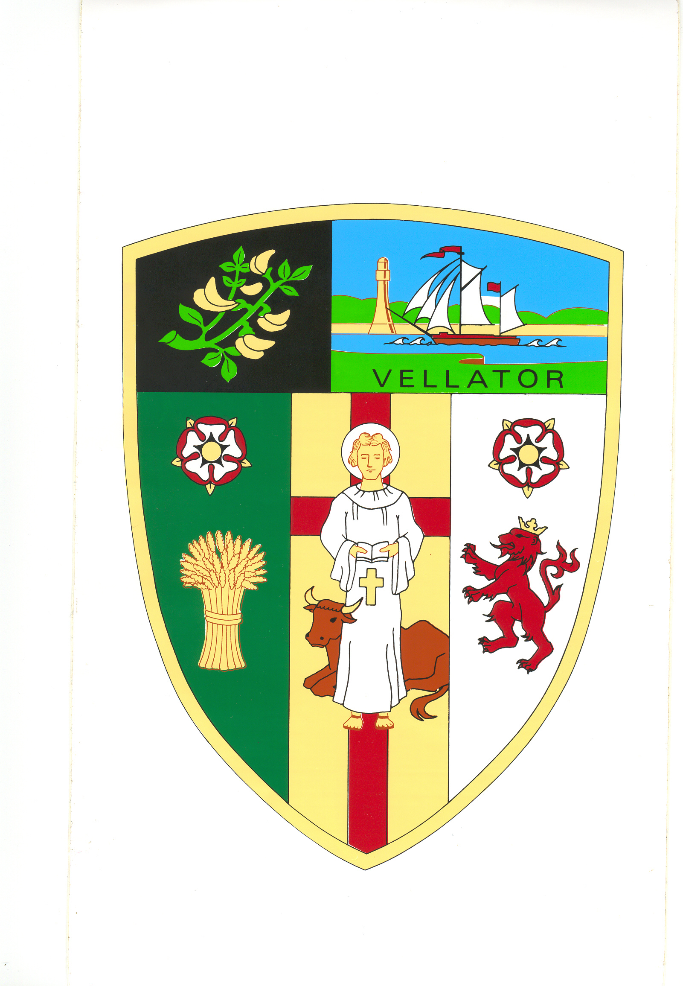
Council Offices
Chaloners Road
Braunton

Date issued: 6 March 2024
Dear members of Braunton Parish Council,

You are summoned to attend the Full Council meeting of Braunton Parish Council, which will be held on TUESDAY 12 MARCH 2024 at 7pm, in the Council Chamber, Chaloners Road, Braunton, for the purpose of transacting the undermentioned business.

In accordance with The Public Bodies (Admission to Meetings) Act 1960 members of the public and press are welcome to attend.

There will be a period not exceeding 15 minutes for questions by the public. Anyone wishing to ask questions is requested to notify the Parish Clerk by 12 noon on the day of the meeting.

Yours faithfully,
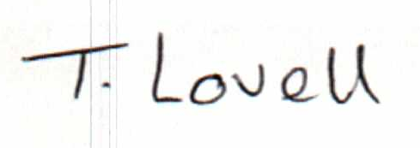

Tracey Lovell BA (Hons)
Clerk to the Council & RFO

Public Participation. In accordance with Standing Order 49 a period not exceeding 15 minutes will be set aside at the start of the meeting for members of the public to ask a question or make a statement about, any matter relating solely to any function of the Council or any planning application being considered by the Council. Anybody wishing to ask a question is requested to inform the Parish Clerk prior to the meeting.
- - - - - - - - - - -- - - - - - - - - - - - - - - - - - - - - - - - - - - - - - - - - - - - - - - - - - - - - - - - - - - - - - - - -

AGENDA
Part A – Public

- Apologies - receive apologies and reasons for absence.

- Receive items for information not on the agenda, which in the opinion of the Chair should be brought to the attention of the Council.

- Declarations of Interest – to receive declarations of personal interest and disclosable pecuniary interests (DPIs) in respect of items on this agenda. Members are reminded that all interests:
- Should be declared at the beginning of the meeting, and
- Declared prior to the item being discussed.

- Public Participation Period – members of the public are permitted to make representations, ask questions and give evidence in respect of any item of business relating to the Parish Council. The period of time which is designated for public participation shall not exceed 15 minutes. Each member of the public is entitled to speak once only in respect of business and shall not speak for more than 3 minutes. A question asked by a member of the public during this period shall not require a response or debate at the meeting.

- Requests for Dispensation - consider requests received for dispensation(s).

- Minutes – To approve and sign Minutes of the Council Meeting held on the 13 February 2024, attached.

- Action Sheet – consider updated action sheet, attached.

- Police Report – receive latest newsletters for February 2024, attached.

- Report from Devon County Councillor – receive Devon County Councillor.

- Report from North Devon Councillors – receive North Devon District Councillors.

- Planning – North Devon Council the determining Authority, has asked for comments from this Parish Council on the following applications (click on the application number to view the Application):

Cllrs E Spear and G Bell in their capacity as North Devon Councillors, stated that any opinions expressed during discussions on the following planning applications represent a preliminary view and that they will naturally reconsider the application fresh when presented all the facts at principal level.
a) | 78351 | Proposed: Relocation of parking space provision  Location: Corner Cottage Hills View Braunton Devon EX33 2LA  Applicant: Mr Ricky Cloke
b) | 78249 | Proposed: Hybrid application – Full detailed application for 3 No. Barn conversions to dwellings together with Outline application for erection of replacement farmhouse as a two-storey dwelling and demolition of existing farm house (appearance and layout reserved)  Location: Higher Halsinger Farm Halsinger Braunton EX33 2NL  Applicant: Mr A Garness
c) | 78350 | Proposed: Application for a non-material amendment to planning permission 77822 (raising of roof and insertion of dormers to create additional accommodation and alterations to include the installation of solar panels and extension to the parking area (amended description)) in respect of increasing the width of the dormers to the East and West elevations  Location: Indiana South Street Braunton Devon EX33 2AS  Applicant: Mr and Miss Stapley and Carter
d) | 78322 | Proposed: Application for a non-material amendment to planning permission 76674 (Variation of condition 2 (approved plans) attached to planning permission 57649 to allow amended design) in respect of revised site/layout and amended design to plots 21, 22 & 23  Location: Land Adjacent 86 Velator Bridge Braunton Devon EX33 2BG  Applicant: Velator Way Ltd
- North Devon Council – Planning Decisions

77477 Description: Application for consent for works to trees covered by a
tree preservation order in respect of Removal of 1 Ash Tree (T1) and
pruning of Holm Oak (T2) Maple (T10) and Holm Oak and Bay (G1)
and two Cherry (G5)
Site Address: Tyspane Nursing Home Lower Park Road Braunton
Devon EX33 2LH
Applicant: Mr Luke Davey
Decision: APPROVED
Decision Date: 19/02/2024

78041 Description: Replacement of dwelling
Site Address: 22 Stallards Braunton Devon EX33 1BP
Applicant: Ms Gvalda
Decision: APPROVED
Decision Date: 21/02/2024

71760 Description: Application for consent for works to trees covered by a
tree preservation order in respect of crown reduction of 2 Cherry and
2 Maple trees
Site Address: Tyspane Nursing Home Lower Park Road Braunton
Devon EX33 2LH
Applicant: Valley Provincial Group
Decision: WITHDRAWN
Decision Date: 20/02/2024

78155 Description: Notification of works to trees in a conservation area to
remove Conifer hedge & replant area with a native species
Site Address: 29 Church Street Braunton Devon EX33 2EL
Applicant: Claire Appleby
Decision: DEEMED CONSENT
Decision Date: 20/02/2024

- Accounts Due for Payment –
- To examine and agree the accounts due for payment, for the period 14 February – 12 March 2024 inclusive – schedule of payments will be issued prior to the meeting.
- To approve direct debit and standing order payments for February 2023 – attached.
- To approve PAYE, NI and pension contributions for March 2023 – schedule of payments will be issued prior to the meeting.

- Representatives on Outside Bodies –
- Receive the Council’s representative Cllr V Cann on the Museum of British Surfing.
- Receive the Council’s representative Cllr M Shapland on Ask for Jake.
- Appoint representative on the Police Councillor Advocates Scheme.
- Appoint representative on the One Northern Devon Local Care Partnership.

- New Play Equipment and improvements to play parks –
- Consider and approve the location of the new play equipment in the Recreational Ground.
- Consider and approve quotation to replace access gate on the Chaloners Road Play Park.

- Devon County Council On-Street Parking Scheme on Exeter Road, Braunton – To consider report submitted to the Devon County Cabinet meeting and agree action to improve County Council issues in Braunton.

- Devon and Torbay Devolution Deal for details of the proposals can be found at the following link Devon and Torbay's deal - Devon and Torbay Devolution Deal (devontorbaydeal.org.uk) – Receive Chairman.

- To ratify decisions taken under delegated powers from 14 February to 12 March 2024, information attached.

- His Majesty the King’s (HMK) Portrait – See briefing note attached.

- Braunton Bowling Club – Consider request for permission to install reflective strips on bridge that accesses the Bowling Club – information attached.

- White Cross Offshore Windfarm Limited (WCOWL) – Receive and consider action in response to the WCOWL letter, attached.

- Hire of the Recreational Ground - Consider request received from Dancing Feet Academy to teach a dance and fitness class on Sunday 2nd June 2024 at the Recreational Ground between 10.30am and 12.30pm.

- Community Shared Space (CSS) –
- Consider request from the North Devon Environment Trust to hire the CSS on Saturday 23 March 2024 to hold their plant and seed swap
- Consider request from the North Devon Environmental Trust to hire the CSS on Sunday 21 April 2024 to for Earth Day event

- To resolve: that under section 1(2) of the Public Bodies (Admission to Meetings) Act 1960 that the public and press be excluded from the meeting for the following item(s) as it involves the likely disclosure of confidential information.

Part B – Exclusion of Press and Public

- Transfer of Public Conveniences – To consider arrangements for the transfer of the public conveniences.

- Unauthorised use and abuse of the Caen Street Car Park – Receive Parish Clerk

