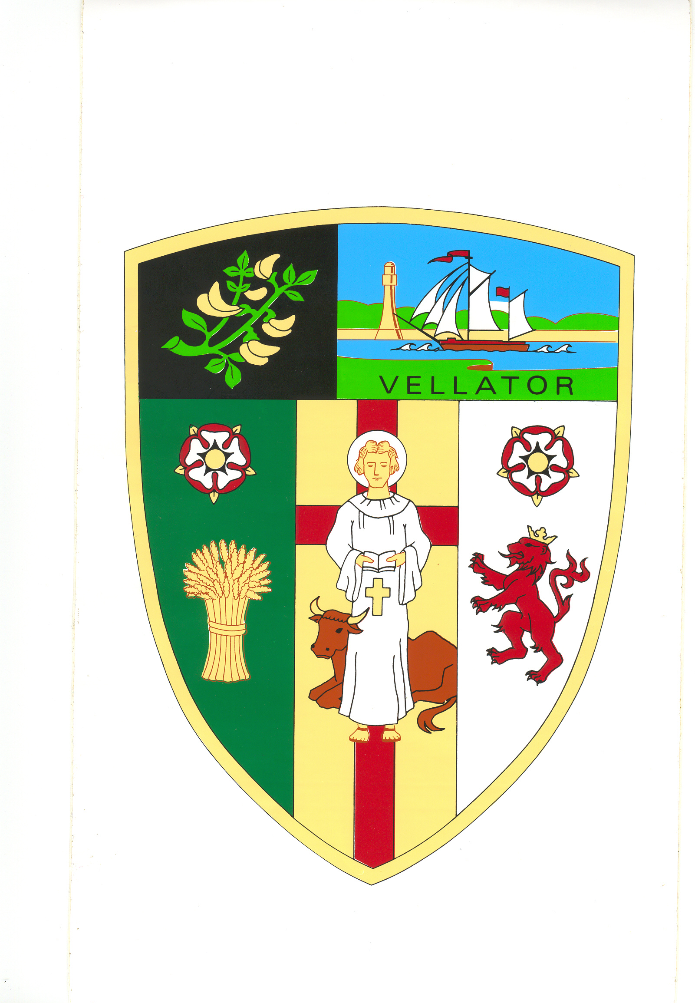
BRAUNTON PARISH COUNCIL

Council Offices
Chaloners Road
Braunton

15 February 2018

Dear Councillors: Spear, Bunyard, De Groot, Parsons, Wood, Chugg, and Mrs Chesters

You are summoned to attend a meeting of the Parks and Gardens Committee in the Council Chamber at 5:30 pm on Wednesday 27 February 2019. The public and press are welcome to attend.
Yours faithfully,

Mrs T Lovell
Clerk to the Council
- - - - - - - - - - - - - - - - - - - - - - - - - - - - - - - - - - - - - - - - - - - - - - - - - - - - - - - - - - - - - -
A G E N D A
Part I – Public

- Receive Apologies.

- Declarations of Interest Councillors are requested to complete the book provided before the meeting.

Interests must be re-declared when the item is called.

- Sign and approve Minutes of the Parks & Gardens Committee meeting held on
10 December 2018, attached.

- Proposed Improvements to the Area Behind the Anchor – Receive Braunton Rotary Club

- Knowle Play Park – Approve quotes for new play equipment

- Village Green Enhancements Project – Update

- Memorial Bench – Consider request for a memorial bench

- ROSPA Play Park Inspections – Approve quote for annual inspection

- Ride On Mower – Consider options to replace ride on mower

