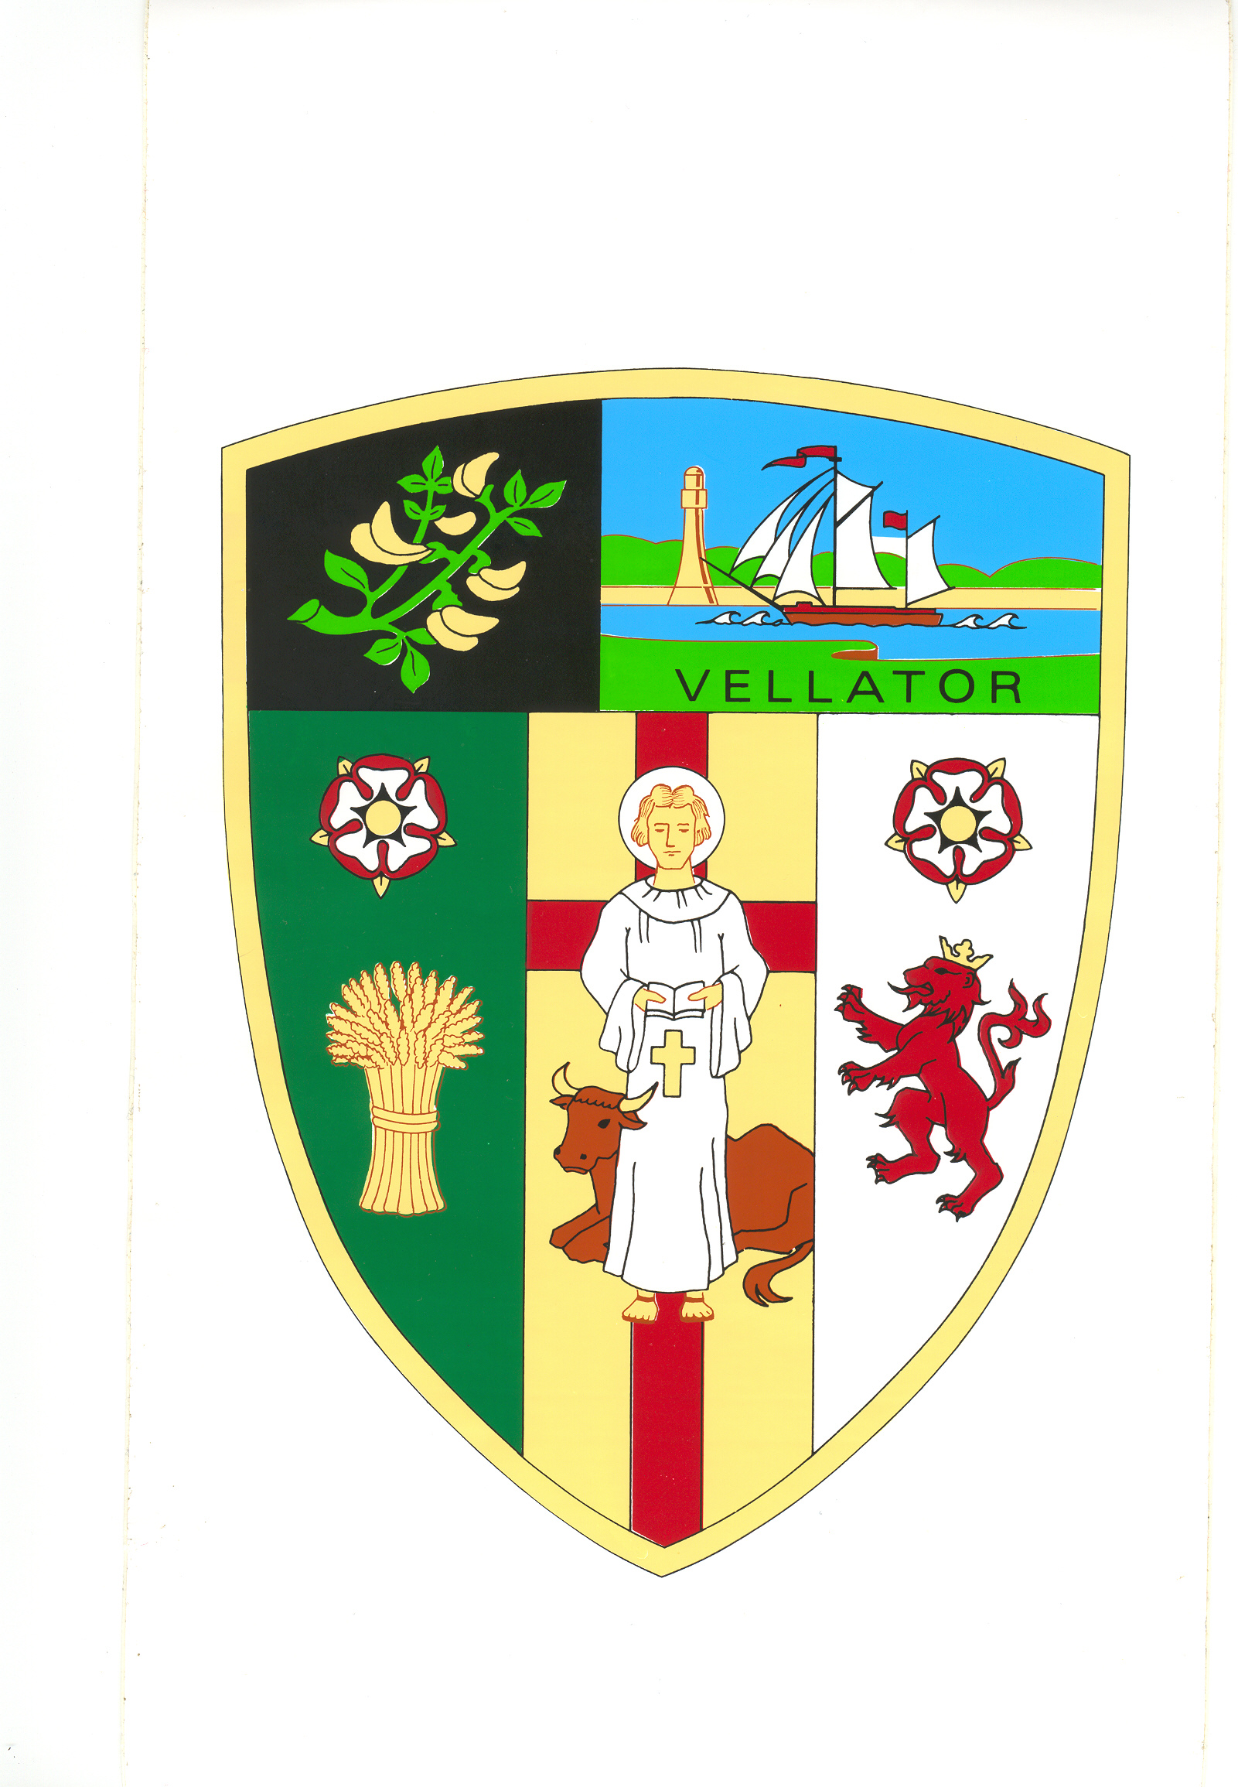
BRAUNTON PARISH COUNCIL

Council Offices
Chaloners Road
Braunton

28 May 2018

Dear Councillors: E Spear, Relph, M Shapland, Bryant, Bunyard, R Shapland, D Spear

You are summoned to attend a meeting of the Parks and Gardens Committee in the Council Chamber at 5:00 pm on Monday 3 June 2019. The public and press are welcome to attend.
Yours faithfully,

Mrs T Lovell
Clerk to the Council
- - - - - - - - - - - - - - - - - - - - - - - - - - - - - - - - - - - - - - - - - - - - - - - - - - - - - - - - - - - - - -
A G E N D A
Part I – Public

- Elect Chair.

- Receive Apologies.

- Declarations of Interest Councillors are requested to complete the book provided before the meeting.

Interests must be re-declared when the item is called.

- Sign and approve Minutes of the Parks & Gardens Committee meeting held on
27 February 2019, attached.

- Village Green i) Update

ii) Open Day

- Summer Planting – Agree costs

- Committee Four-Year Development Plan – Consider year one.

