BRAUNTON PARISH COUNCIL
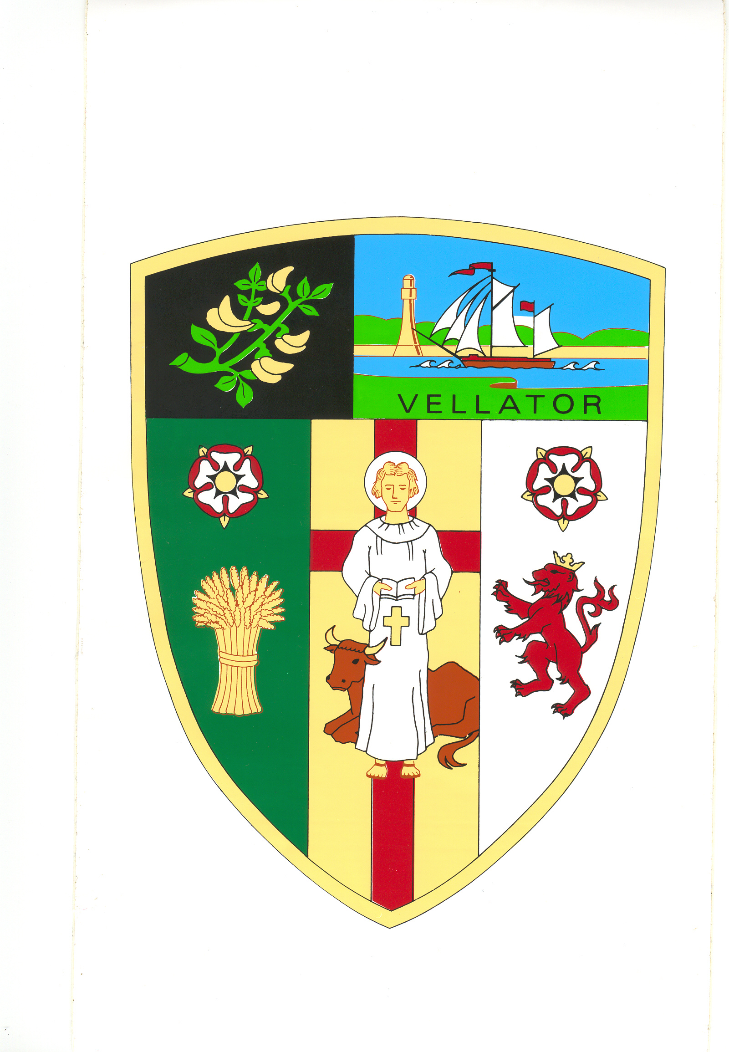
Council Offices
Chaloners Road
Braunton
North Devon
EX33 2ES

16 April 2019
Dear Councillor,

You are summoned to attend the Additional Council Meeting of Braunton Parish Council, which will be held on TUESDAY 23 APRIL 2019 AT 7 PM, in the Council the Chamber, Chaloners Road, Braunton, for the purpose of transacting the undermentioned business.

In accordance with The Public Bodies (Admissions to Meetings) Act 1960 members of the public and press are welcome to attend.

Yours faithfully,

Mrs T Lovell
Clerk to the Council

Public Participation. In accordance with Standing Order 49 a period not exceeding 15 minutes will be set aside at the start of the meeting for members of the public to ask a question or make a statement about, any matter relating solely to any function of the Council or any planning application being considered by the Council. Anybody wishing to ask a question is requested to inform the Parish Clerk prior to the meeting.
- - - - - - - - - - -- - - - - - - - - - - - - - - - - - - - - - - - - - - - - - - - - - - - - - - - - - - - - - - - - - - - - - - - - - - - -

A G E N D A
- Receive apologies.

- Items not on the agenda, which in the opinion of the Chairman should be brought to the attention of the Council.

- Declarations of interest

Councillors are requested to complete the book provided before the meeting.

Interests must be re-declared when the item is called.

- Finance (a) Draw Cheques.

- Planning see attached.

