BRAUNTON PARISH COUNCIL
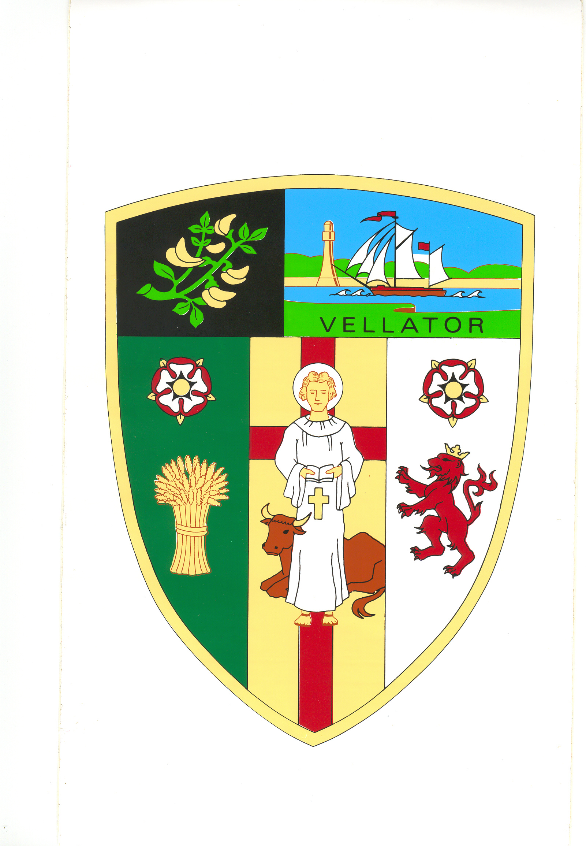
Council Offices
Chaloners Road
Braunton

14 January 2019

Dear Councillors: D Spear, Bunyard, De Groot, E Spear, Bradford, Shapland and Wood

You are summoned to attend the Property Committee Meeting of Braunton Parish Council, which will be held on TUESDAY 22 JANUARY 2019 at 6 pm, in the Council Chamber, Chaloners Road, Braunton, for the purpose of transacting the undermentioned business.

In accordance with The Public Bodies (Admissions to Meetings) Act 1960 members of the public and press are welcome to attend.

Yours faithfully,

Mrs T Lovell
Clerk to the Council
- - - - - - - - - - - - - - - - - - - - - - - - - - - - - - - - - - - - - - - - - - - - - - - - - - - - - - - - - - - - - -

A G E N D A

- Receive apologies.

- Declarations of Interest - Councillors are requested to complete the book provided before the meeting.

Interests must be re-declared when the item is called.

- Sign and approve Minutes of the Property Committee meeting held on 21 August 2018, attached.

- Energy Savings – Consider quotes for replacing LED lighting in Parish office and surrounding areas.

- Parish Hall maintenance a) Approve costs to decorate the front of the Parish Hall

b) Approve costs to replace speaker

- Railway Signal – Approve the Coombe Rail CIC to carry out maintenance in the spring.

