BRAUNTON PARISH COUNCIL
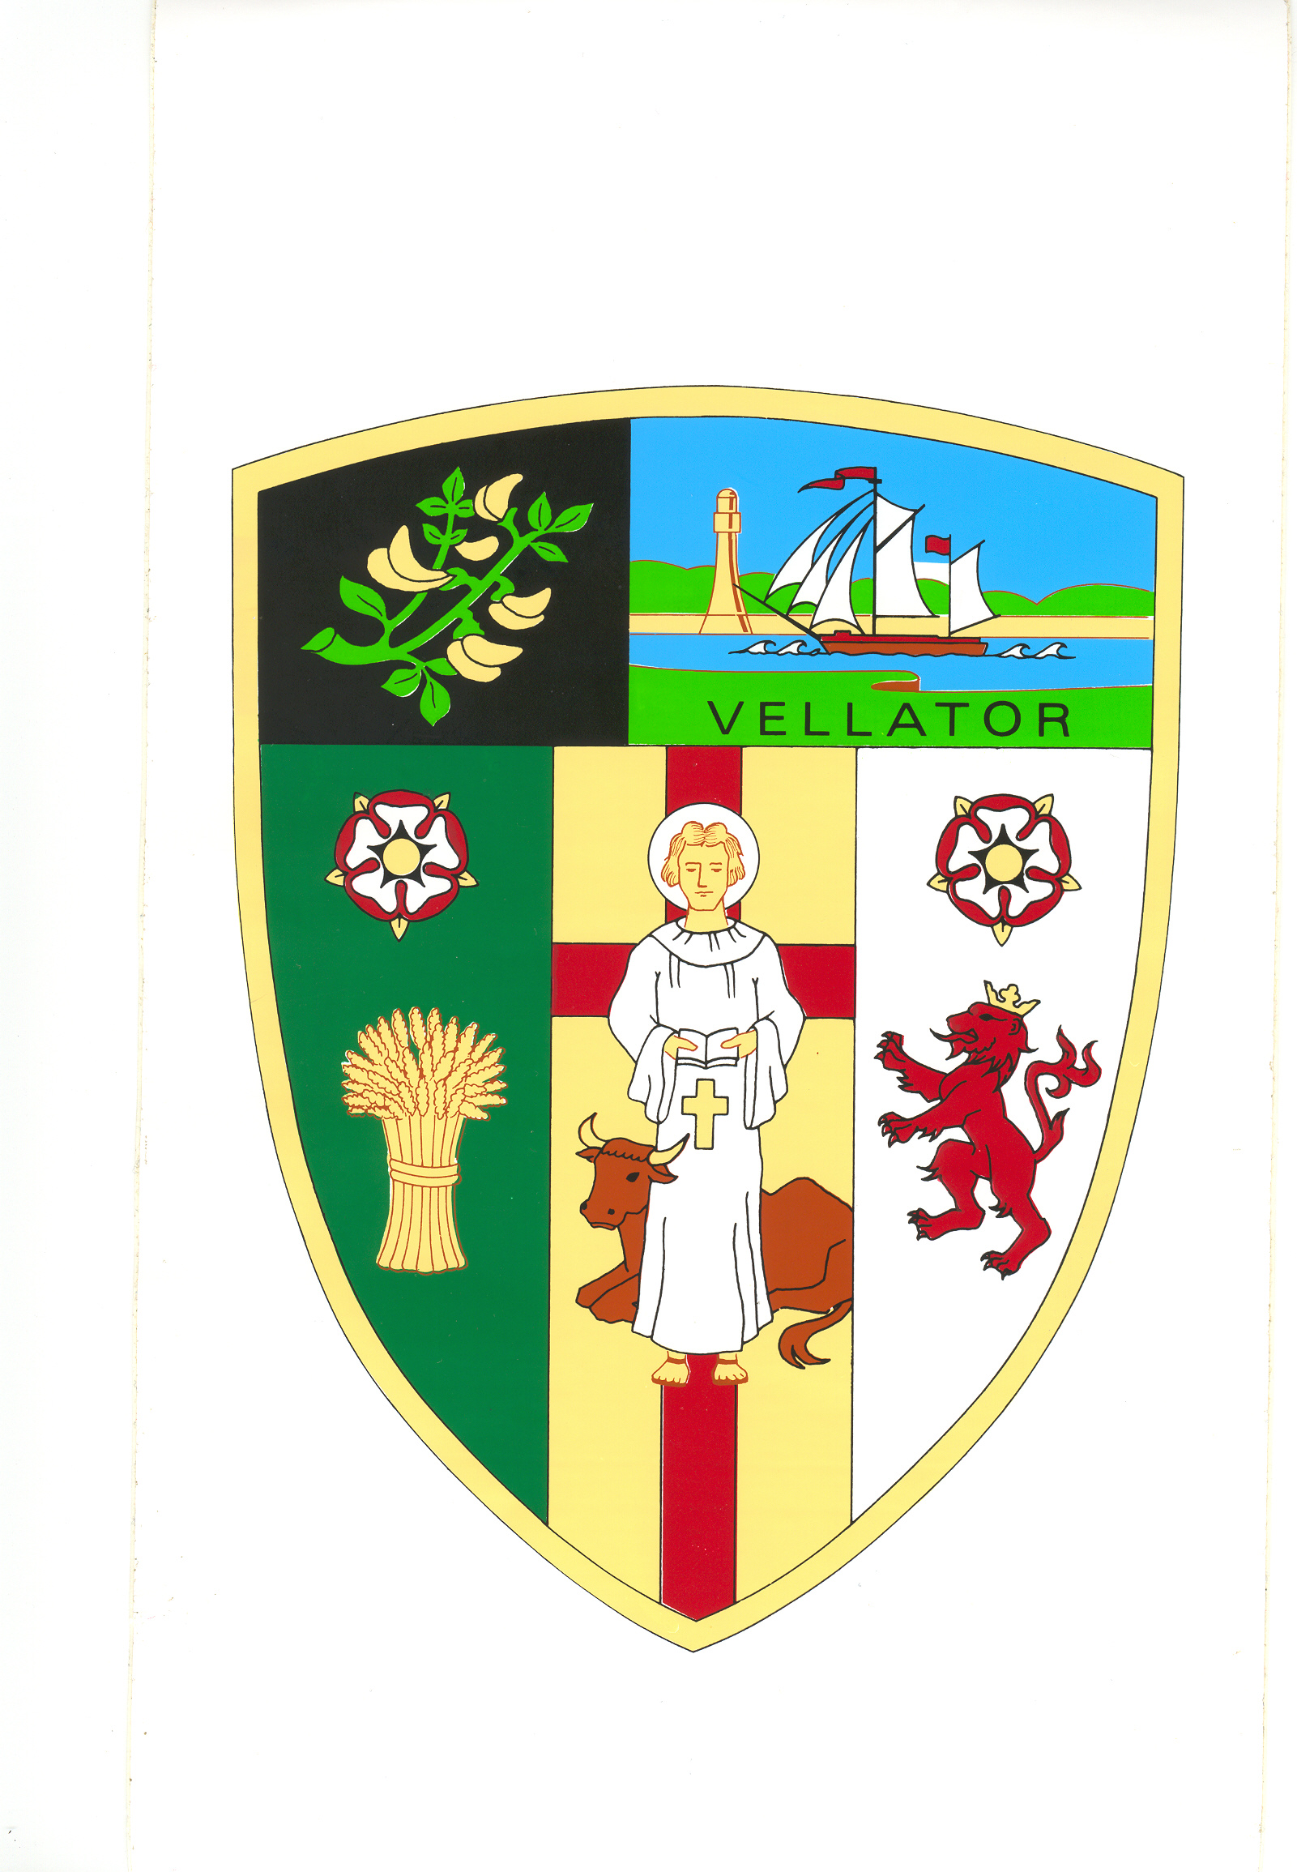
Council Offices
Chaloners Road
Braunton

12 June 2019

Dear Councillors: E Spear, Relph, M Shapland, Bryant, Mrs Chesters, R Shapland and Wood

You are summoned to attend the Property Committee Meeting of Braunton Parish Council, which will be held on TUESDAY 18 June 2019 at 6 pm, in the Council Chamber, Chaloners Road, Braunton, for the purpose of transacting the undermentioned business.

In accordance with The Public Bodies (Admissions to Meetings) Act 1960 members of the public and press are welcome to attend.

Yours faithfully,

Mrs T Lovell
Clerk to the Council
- - - - - - - - - - - - - - - - - - - - - - - - - - - - - - - - - - - - - - - - - - - - - - - - - - - - - - - - - - - - - -

A G E N D A

- Elect Chair.

- Receive apologies.

- Declarations of Interest - Councillors are requested to complete the book provided before the meeting.

Interests must be re-declared when the item is called.

- Sign and approve Minutes of the Property Committee meeting held on 22 January 2019, attached.

- Railway Signal – Approve costs to carry out maintenance.

- Memorial Seat – Consider request received.

- Committee Four-Year Development Plan – Consider year one.

