BRAUNTON PARISH COUNCIL
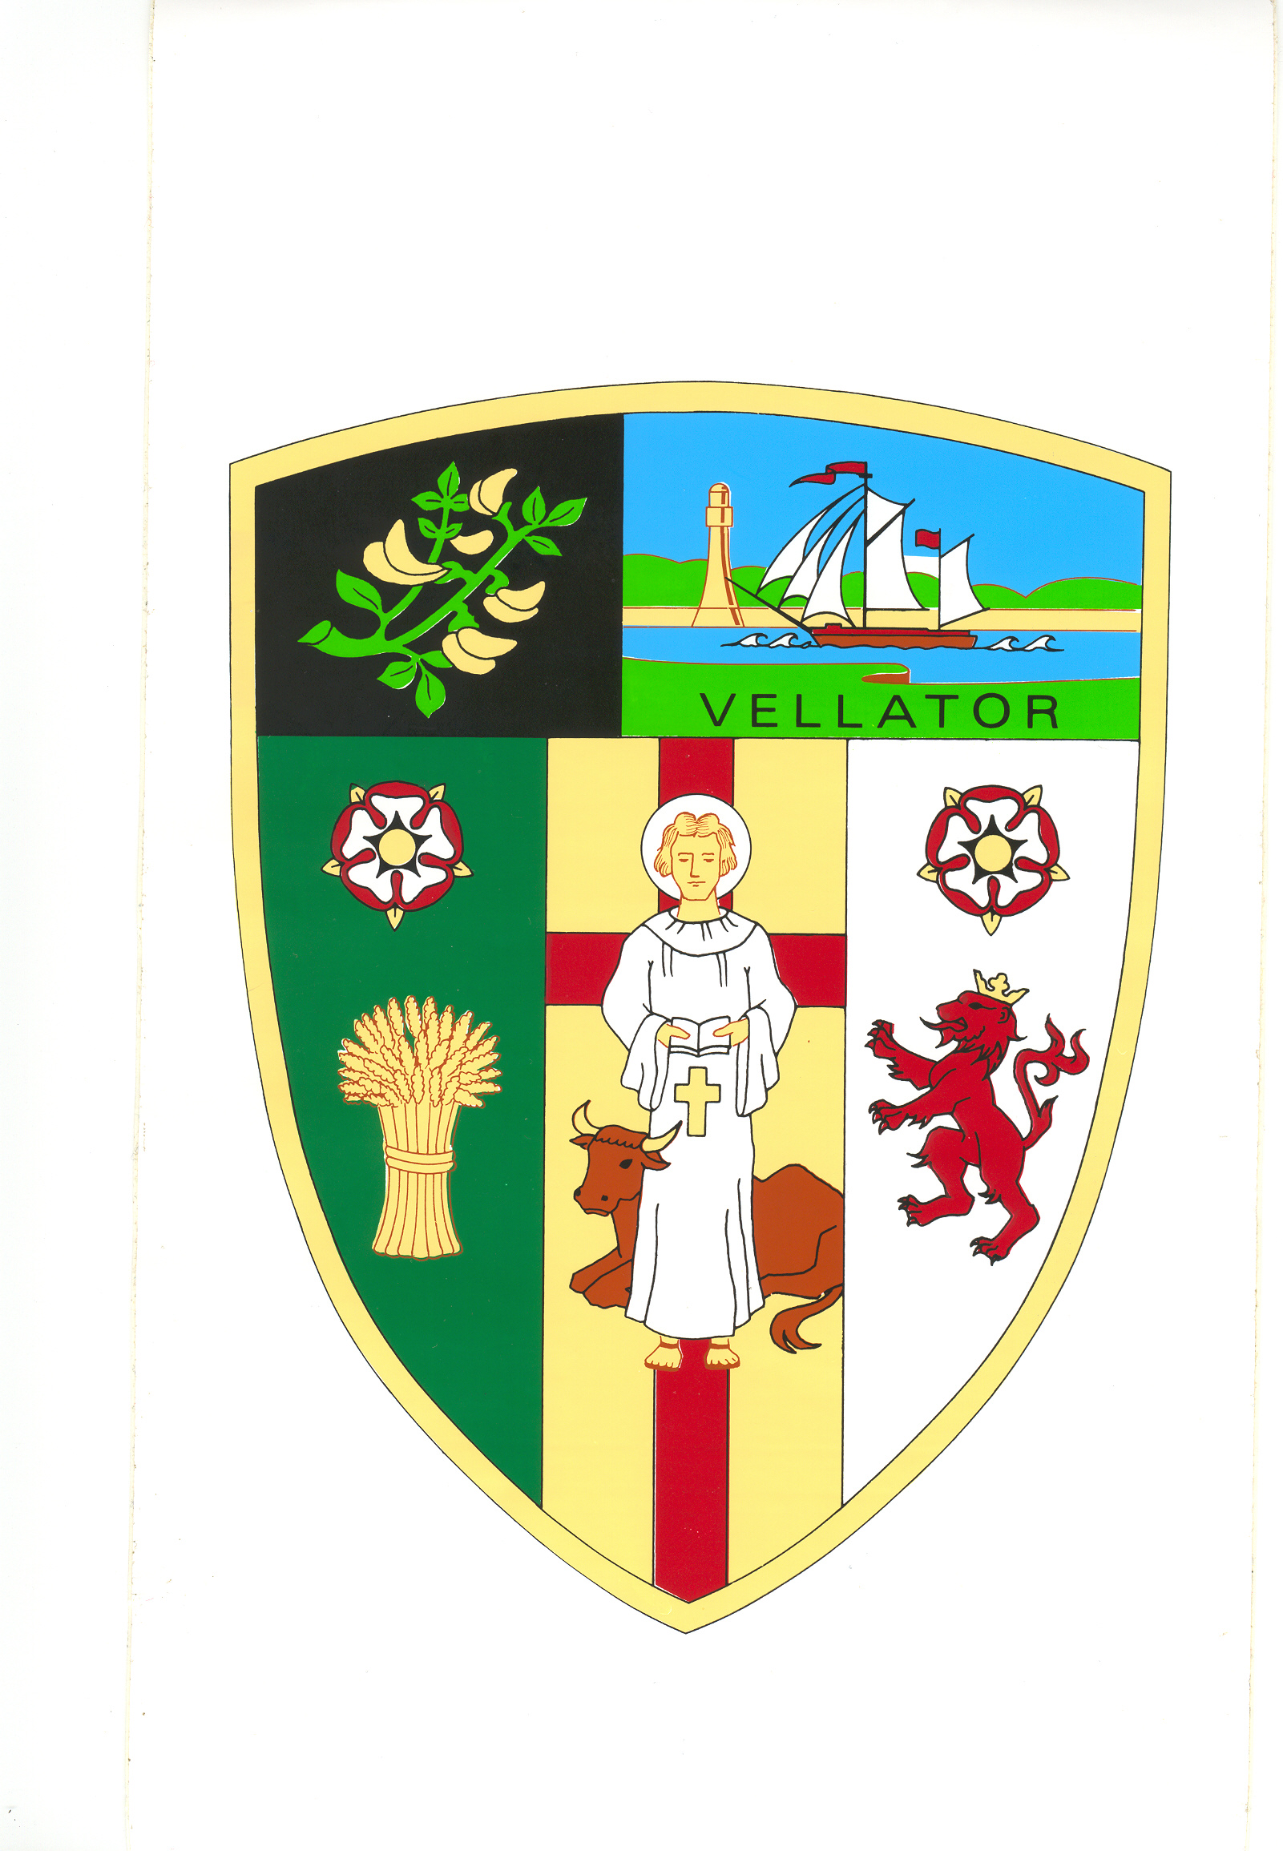
Council Offices
Chaloners Road
Braunton
Devon
EX33 2ES

Telephone: 01271 812131
Email: info@brauntonparishcouncil.gov.uk
Website: www.brauntonparishcouncil.gov.uk

Date of issue: 3 December 2021

Dear Councillors: E Spear, D Relph, M Shapland, E Wood and R Shapland, A Bryant, J Chesters.

You are hereby summoned to attend a VIRTUAL meeting of the Property Committee, which will be held on TUESDAY 7 DECEMBER 2021, at 3 pm via video conference at the following link for the purpose of transacting the undermentioned business.

https://us02web.zoom.us/j/84363622330?pwd=K0dlRXZFc0JqM3lnSWZKNENrRTVDQT09

Meeting ID: 843 6362 2330
Passcode: 581125

In accordance with The Public Bodies (Admissions to Meetings) Act 1960 members of the public are welcome to attend. If you would like to attend the meeting, you can use the link shown or contact the Council office for further information and assistance on joining.

Yours faithfully,
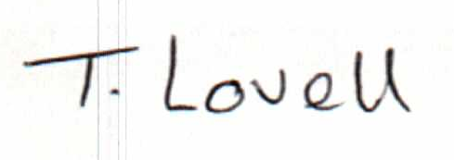

Tracey Lovell BA (Hons)
Clerk to the Council & RFO

- - - - - - - - - - -- - - - - - - - - - - - - - - - - - - - - - - - - - - - - - - - - - - - - - - - - - - - - - - - - - -

AGENDA
Part I – Public

- Apologies – Please make apologies known to the Clerk.
- Declarations of Interest – To receive declarations of personal interests and disclosable pecuniary interests (DPIs) in respect of items on this agenda. Members are reminded that all interests:
- Should be declared at the beginning of the meeting, and
- Declared prior to the item being discussed.

- Minutes Approve and sign the minutes of the Property Committee meeting held on 8th November 2021, attached.

- Committee Budget 2022/23 – preliminary discussions, revised draft budget attached.

